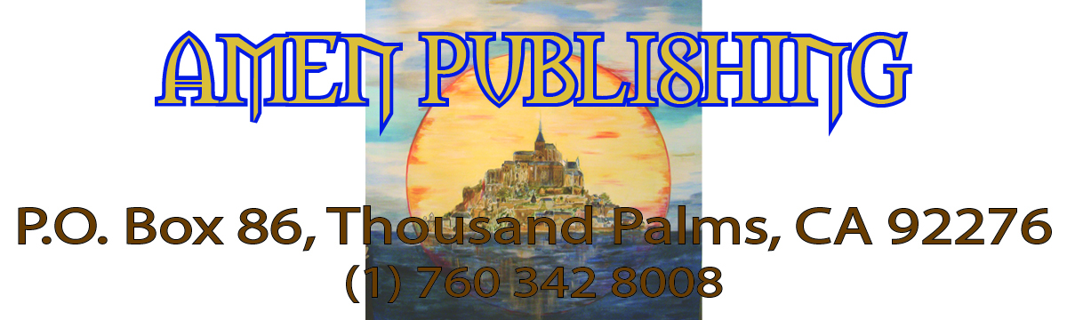

Greetings Dear Ones:

One more year, the world was not obliterated and you still have to face your journey, work and raise a family! Not fun? Well it depends on how you want to look at it and if you have made the right decisions.

Here, at the Sanctuary, we definitely had a breakthrough! The last group arrived early and then we had the retreat. Almost two weeks together in harmony, fun and love. Cooking, cleaning, shopping, fasting, meditating, having fun, all was easy.

We have focused on cleaning the land, adding light fixtures as well as blue and white paint. Good symbols, right!? B. played the didgeridoo with an irrigation pipe, while we were toning. We burned a list of everything that we want to let go of. I slowly gave to the flames the 52 cards of a precious 35 years old Tarot deck. This was a symbol of My decision and focused work to dissolve and extinguish the energy field of magic that have been built over the Earth throughout centuries of manipulation and lack of self-love. May you all surrender, without fear, into the Creator’s loving embrace and you will receive everything that you need.

Thanks to all our (your and Mine) individual efforts, self-introspection, etc, we have been surfing the wave of Love coming from the Cosmic Man (My Higher-Self) and the Planets. May you feel it individually and receive the blessings that are available to all.

At the end of this year, I want to express my love and gratitude to each member of the Michael’s Family, with a special thanks to all the people who have been supporting the Sanctuary and Myself financially and physically. Not only, the property looks better and better, but every day and every minute, I witness/see and give thanks for someone’s efforts or gifts. You are thus with Me all the time, through a page or picture on the internet, a plant that you put into the ground, a postcard or an object in the house and are blessed by the Divine.

Comment about the nature of an Avatar: In spite of My simple and fun nature , it is still obvious that most people, new comers or old Family members feel a little overwhelmed or intimidated by My powerful Presence –palpable in 3D- and by the fact that ‘I know exactly what I want’! But, the contrary would be surprising. It is quite impossible to hide the power of an Archangel. Also, I am the Holder of the Divine Plan and My Will anchors Divine Will for this Galaxy. Therefore, I naturally embody What Is and What is To Be. Difficult to pretend, even in daily human life … So, let us smile about it and make sure that more people, ready for spiritual adulthood and true love join us.

For 2013, the keynotes are:
The Cosmic Man has completed His part of the work, when He changed His energetic constitution. On the Inner Planes, the Lodge changed its trajectory. Everything has been set for the reconstruction on the foundation of Love and the Light. The leadership was taken back by the Michaelic team, that is to say by the Light. It is then your responsibility to organize your spiritual life and your journey in the body in congruence with those events. The next months might be a challenge for those whose life is focused on material things and on chakras 2 and 3. Make sure that you are not swimming upstream. Practice sharing and faith.

CHANGE YOUR POINT OF VIEW
In order to exit duality, make sure to reframe the information, specifically about the Illuminati and the Lodges. Most articles published in the Web about the leading families, Illuminati, NOW are based on a dualistic point of view. The dark lodges, the Illuminati have only done what they could or had to do, considering the karmic and vibratory level of the Earth and of Humankind. Who, what Company, in 2013, is clear enough to serve and give without taking something: a commission, a financial relief, comfort for the ego or some power?

The people serving the Illuminati, the leading families are believed to be responsible of all evils. If they support a university, it is because they want to control and brainwash the students; if they build something, they want to impose hidden codes and use astrology. You could instead be grateful because they offer a beautiful, useful structure. Also, they have kept the tradition alive while the world had forgotten. They have supported education or prayer, while giving some of their wealth. And you, what have you done to advance the general state of the Planet? Were you even capable of helping? Well, let us all be positive and accept the perfection of each moment!

2013 SCHEDULE (Call for precise dates and rates)

February: workshop FUSION of the FIRES, in Brussels and Frankfurt areas.

May: Wesak, Avatar Celebration, Retreat at the Sanctuary.

June: Workshop South of France

August: workshop Stockholm

September Equinox: Festival of the Light and of the Archangel at the Sanctuary and trip in Louisiana and Texas.

We are now organizing the September Equinox trip for 2013 (Between September 16th and 25th). Remember that Louisiana belonged to France and was sold to the emerging colonies by Napoleon.

We envision 9 nights, rental cars and a lot of discoveries for the European travelers. 4 stars Hotels whenever possible. They are unusual and exciting sites and information on the internet. If you have any wish or suggestions for the trip, please let us know. In order to ease the booking process, we would like to have an approximate number of attendees. Please contact me for more information aamkl@archangel-michael.us or even better by phone (1) 760 342 8008.

Have a blessed 2012 and allow love to flow.

Archangel Michael

